Instructions for the Submission of

Required Base Budget Adjustments

2016-2018 Biennial Budget



Department of Planning and Budget
August 2015
TABLE OF CONTENTS

Overview of Base Budget Adjustments 1
Budget Calendar 1
About 2016-18 Base Budgets 2
Obtaining Base Adjustment Targets 3
Personal Services 4
Benefit Rates 4
Nonpersonal Services 5
Detailed Nonpersonal Services Subobject Codes 5
Allowable Nonpersonal Services Convenience Codes 6
Reports 7
Base Budget Adjustment Module Instructions 8
Base Budget Adjustment Module Quick Guides 8
Overview Tab Overview 9
Overview Tab Instructions 9
Budget Detail Tab Overview 10
Budget Detail Tab Instructions 10
Position Planning Tab Overview 11
Position Planning Tab Instructions 11
Base Budget Adjustment Bulk Submit Instructions 14
Bulk Submit Overview 14
Bulk Submit Instructions 14

Overview of Base Budget Adjustments

These instructions provide guidance to address the next step in the preparation of the Governor’s introduced budget for the 2016-2018 biennium -- the submission of required base budget adjustments. Submissions are due to DPB by August 31, 2015.
This submission is one of two that are due at the end of August. The submission covered in these instructions involves technical changes to your agency’s budget that have been identified by DPB in the form of base budget adjustment targets. The other submission is for technical adjustments to your agency’s budget that you have identified and that have not already been included in base budget adjustment targets. Please see the separate instructions on DPB’s website (http://dpb.virginia.gov or http://dpb.virginia.gov/forms/forms.cfm?search=%202016%20Technical%20Adjustments%20Instructions) for more information on the technical adjustments submission.
Base budget adjustments consist of required changes to your 2016-2018 base budget as identified by DPB. Base budget adjustments include items such as:
- The removal of one-time costs;
- Net zero transfers of dollars or positions;
- The annualization of partial year spending or reductions;
- The shifting of funds or positions between programs;
- The addition of nongeneral fund appropriation to reflect actions already approved administratively;
- The increase in position level to reflect actions already approved administratively; and
- The distribution of Central Appropriation amounts to agency budgets.
DPB has created targets for base budget adjustments and you will use the Base Budget Adjustment module in the Performance Budgeting system to spread these adjustment targets to the appropriate programs, service areas, fund details, and subobjects. In addition, you may also use the Base Budget Adjustment Bulk Submit to DPB module to manage and submit all adjustments to DPB at one time. Instructions for using these modules are included in this package.
The base adjustment targets are embedded within the base adjustment module and can also be found listed on the DPB website at the following link: http://www.dpb.virginia.gov/forms/20150803-2/2016-18_BaseAdjustmentsTargets.xls. For more information, see the “Obtaining Base Adjustment Targets” section of these instructions.
These adjustments will be made against base budgets that were established and loaded by DPB in June. For more information about the base budget loaded in June see the “About 2016-18 Base Budgets” section of these instructions.

Budget Calendar

For a complete view of the budget calendar for the remainder of the summer, please visit the DPB Website (or go directly to http://dpb.virginia.gov/forms/20130426-2/BudgetCalendarAgency.pdf ).

About 2016-18 Base Budgets

This year instead of agency-based submissions, DPB has loaded each agency’s base budget using the FY 2016 appropriations contained in Chapter 665, the 2015 Acts of Assembly. In the past, the subobject level breakdown of data has typically matched subobject details of the previous Chapter. This year, the subobject detail was determined using the proration of actual expenditures over the past three years, where applicable. This approach was taken with the expectation of bringing the detail data more in line with actual usage of appropriations. Often, the budget development processes result in a wide variety in the quality of base budget submissions. In some cases, the same convenience codes and other irregularities get rolled forward year after year. Using expenditure data to help populate the base budgets for each agency will hopefully result in a more consistent approach that might be more grounded in reality with how the funds are actually spent. To view your base budget as loaded by DPB, you can run the BD1.17 - Agency Budget Requests report within the Performance Budgeting system. See the “Reports” section of these instructions for more information.
As was previously indicated, your base adjustments will be applied to the centrally loaded base budget. If you need to make a change to the base budget that is technical in nature and has not already been covered by a base budget adjustment target, your opportunity to do so is via the separate technical adjustment submission.

Obtaining Base Adjustment Targets

The first step prior to beginning your submission is for you to obtain a listing of the base budget adjustment targets created by DPB. You may obtain these targets by downloading an Excel file from the DPB website containing your agency’s targets.
Follow these steps to use the Excel targets listing:
- Download a copy of the Excel file from http://www.dpb.virginia.gov/forms/20150803-2/2016-18_BaseAdjustmentsTargets.xls
- After opening the file, if you see a security warning at the top of the screen or a pop-up security warning, click “Enable Content”. This will enable the macros within the file that allow you to see the content.
- Enter your three-digit agency code in the yellow shaded box under the “Agy Code” heading and click “Enter”, “Tab”, or arrow out of the shaded cell.
- The spreadsheet should populate with a listing of the base adjustment targets for which you will need to create individual base budget adjustment submissions.
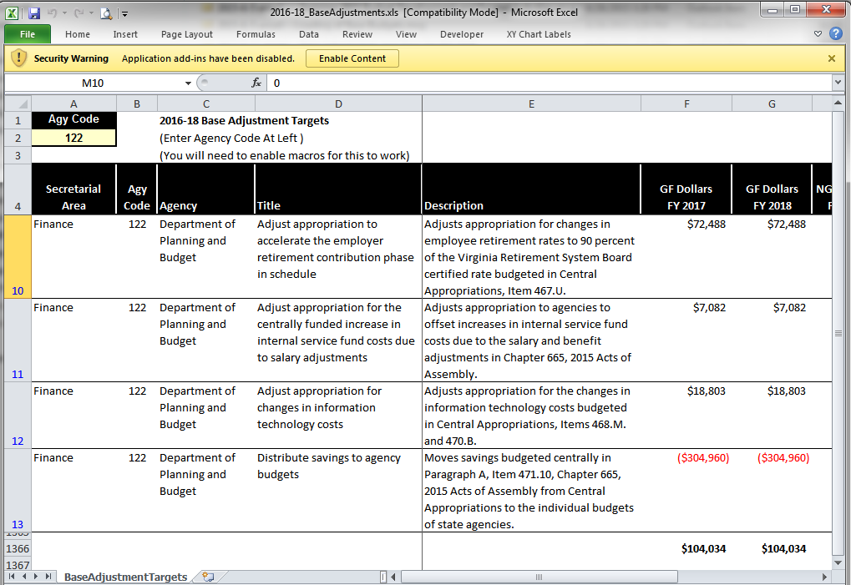

Personal Services

Benefit Rates
If any of your base adjustments involve personal services, you should use the rates included in the table below as applicable.
Sub Object | Benefit |  |  |  | 2016-18 Budget Development  Rates/Factors¹
1111 | VRS Retirement Contributions
 | State Employees |  |  |  | 14.22%*
 | Virginia Law Officers Retirement (VaLORS) |  |  |  | 19.00%*
 | State Police (SPORS) |  |  |  | 27.83%*
 | Judges (JRS) |  |  |  | 50.02%*
1112 | Social Security ² |  |  |  | 6.20% capped at $118,500
1112 | Medicare |  |  |  | 1.45%
1114 | Group Life |  |  |  | 1.19%
1115 | Annual Employer Health Insurance Premiums
 |  | COVA Care |  | Single | $6,519
 |  |  |  | Employee + One | $11,676
 |  |  | Family |  | $17,124
 |  | COVA High Deductible |  | Single | $5,580
 |  |  |  | Employee + One | $10,368
 |  |  | Family |  | $15,144
 | HealthAware |  | Single |  | $6,519
 |  |  | Employee + One |  | $11,676
 |  |  | Family |  | $17,124
 |  | Kaiser Permanente |  | Single | $6,168
 |  |  |  | Employee + One | $10,956
 |  |  |  | Family | $16,020
1116 | Retiree Health Insurance Credit Premium |  |  |  | 1.05%
1117 | VSDP & Long-Term Disability Insurance |  |  |  | 0.66%
1118 | Teachers Insurance and Annuity³ Plan 1 |  |  |  | 10.40%
1118 | Teachers Insurance and Annuity³ Plan 2 |  |  |  | 8.50%
1119 | Defined Contribution Plan⁴ |  |  |  | 10.40%
1138 | Deferred Compensation Match Payments |  |  |  | One-half of employee’s contribution per pay period, up to a max of $20 per pay period or $480 annually
¹ Percentages refer to percent of salaries. Health insurance premiums are the annual employer dollar cost for an individual.
² The Social Security cap applies to calendar year 2015. Future year caps are unknown at this time.
³ For institutions of higher education: This includes alternative retirement options, such as TIAA-CREF, for those employees as defined in § 51.1-126 of the Code of Virginia. Plan 1 employees are those employees hired before July 1, 2010. Plan 2 employees were hired after June 30, 2010.
⁴ Used for employees eligible for a defined contribution plan established pursuant to § 51.1-126.5 of the Code of Virginia.

Nonpersonal Services

For nonpersonal services, you should array any applicable changes by major object of expenditure unless a more detailed subobject detail is utilized in your base budget. In order to obtain more detailed and accurate information about selected expenses, you should use the subobject codes listed below, especially if they have been used in your base budget and if they are applicable to your anticipated expenses. The purpose of collecting budget information at the more detailed subobject level for these selected subobject codes is to better identify these areas of cost and to more completely understand the impact of agency based rate changes. In other cases, the subobject detail represents an area targeted for cost control and/or management, or an area where better tracking of costs are needed.
Any remaining dollar amount for nonpersonal services beyond those required in the list below may be grouped in the “xx95” convenience codes, which are listed on the following page. No other convenience subobject codes may be used.
Detailed Nonpersonal Services Subobject Codes

1205 | Seat Management Services
1214 | Postal Services
1215 | Printing Services
1216 | Telecommunications Services (provided by VITA)
1217 | Telecommunications Services (provided by non-state vendor)
1218 | Telecommunications Services (provided by another state agency)
1241 | Auditing Services
1242 | Fiscal Services
1243 | Attorney Services
1244 | Management Services
1245 | Personnel Management Services
1246 | Public Informational and Public Relations Services
1247 | Legal Services
1248 | Media Services
1271 | Information Management Design and Development Services (provided by VITA)
1272 | VITA Pass Thru Charges
1273 | Information Management Design and Development Services (provided by another State agency (not VITA) or vendor)
1274 | Computer Hardware Maintenance Services
1275 | Computer Software Maintenance Services
1276 | Computer Operating Services (provided by VITA)
1277 | Computer Operating Services (provided by another State agency (not VITA) or vendor)
1278 | VITA Information Technology Infrastructure Services (Provided by VITA)
1279 | Computer Software Development Services
1292 | VITA Services Provided to Out of Scope Agencies
1321 | Coal
1322 | Gas
1323 | Gasoline
1324 | Oil
1325 | Steam
1326 | Wood Fuels
1431 | Categorical Aid to Local Governments and Constitutional Officers (Not Technology)
1432 | Payments in Lieu of Taxes
1433 | General Revenue Sharing
1434 | Disaster Aid to Local Governments
1435 | Special Payments to Localities
1436 | Categorical Aid to Local Governments and Constitutional Officers for Technology
1441 | Payments to Substate Entities
1442 | Payments to Individuals
1451 | Grants to Intergovernmental Organizations
1452 | Grants Nongovernmental Organizations
1453 | Out-of-State Political Entities
1455 | Disaster Cost Reimbursements to Other State Agencies
1456 | Disaster Aid to Nongovernmental Organizations
1511 | Aircraft Insurance
1512 | Automobile Liability
1513 | Flood Insurance
1514 | Inland Marine Insurance
1515 | Marine Insurance
1516 | Property Insurance
1517 | Boiler and Machinery Insurance
1521 | Computer Capital Leases
1522 | Central Processor Capital Leases
1523 | Computer Software Capital Leases
1524 | Equipment Capital Leases
1525 | Building Capital Leases
1526 | Land Capital Leases
1527 | Land and Building Capital Leases
1531 | Computer Rentals (not mainframe)
1533 | Computer Software Rentals
1534 | Equipment Rentals
1535 | Building Rentals
1536 | Land Rentals
1537 | Land and Building Rentals
1538 | Building Rentals – State Owned Facilities
1539 | Building Rentals – Non-State Owned Facilities (Payment administered by DGS)
1542 | Electrical Service Charges
1543 | Refuse Service Charges
1544 | Water and Sewer Service Charges
1547 | Private Vendor Service Charges
1551 | General Liability Insurance
1552 | Money and Securities Insurance
1553 | Medical Malpractice
1554 | Surety Bonds
1555 | Workers' Compensation
1561 | Computer Peripheral Installment Purchases
1562 | Computer Processor Installment Purchases
1563 | Computer Software Installment Purchases
2211 | Desktop Client Computers (microcomputers)
2212 | Mobile Client Computers (microcomputers)
2214 | Mainframe Computers and Components
2215 | Network Servers
2216 | Network Components
2217 | Other Computer Equipment
2218 | Computer Software Purchases
2219 | Development Tools Purchases
3111 | Bond Issuance Expenses
3112 | Bond Issuance Fees
3113 | General Obligation Bond Financing
3114 | General Obligation Bond Interest Retirement
3115 | Revenue Bond Financing
3116 | Revenue Bond Interest Retirement
3117 | Revenue Bond Principal Retirement
3121 | Anticipation Loan Interest Retirement – Not drawdown or mortgage loans
3131 | Anticipation Loan Interest Retirement – Drawdown and Mortgage Loans
3132 | Mortgage Loan Interest Retirement
3196 | Indirect Cost Recoveries from Auxiliary Programs for Obligations
3198 | Inter-Agency Recoveries for Obligations
3199 | Intra-Agency Recoveries for Obligations

Allowable Nonpersonal Services Convenience Codes

1295 | Undistributed Contractual Services
1395 | Undistributed Supplies and Materials
1495 | Undistributed Transfer Payments
1595 | Undistributed Continuous Charges

2195 | Undistributed Property and Improvements
2295 | Undistributed Equipment
2395 | Undistributed Plant and Equipment
3195 | Undistributed Obligations

Reports

In addition to the previously mentioned Excel file (http://www.dpb.virginia.gov/forms/20150803-2/2016-18_BaseAdjustmentsTargets.xls) for obtaining your agency’s base budget adjustment targets, you will also be using the multi-purpose BD1.17 - Agency Budget Requests Performance Budgeting system report for viewing base budget adjustment work items that you have already created and for viewing details about your base budget. This report contains several options that allow you to run detailed reports on requested dollar amounts and authorized positions. In addition, the screen print below shows that there are options that allow the viewing of summarized information and the creation of a formatted report.
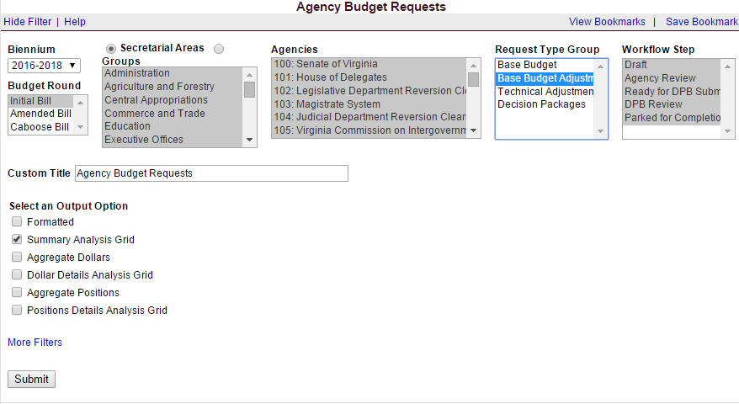
To view information on your base budget adjustment work items in the Performance Budgeting system, choose the “Base Budget Adjustment” selection in the “Request Type Group” filter. Likewise, if you want information regarding your base budget, choose “Base Budget”.

Base Budget Adjustment Module Instructions
Performance Budgeting System

To access the base budget adjustment module, select “Base Budget Adjustment” under the “Operating Budget” menu. This will open an empty base budget adjustment work item. At any time you may submit or save the work item as indicated in the instructions below. The work item will then be available in the work tray for you and others with the same permissions in the Performance Budgeting System.

If you have any questions of a policy nature, please contact your DPB budget analyst. If you experience technical issues with the Performance Budgeting System, please contact the VCCC help desk at vccc@vita.virginia.gov (make sure to indicate in the subject line that you are experiencing a Performance Budgeting System issue so the ticket can be routed to the Performance Budgeting System help desk).
Base Budget Adjustment Module Quick Guides

AGENCY ANALYST QUICK GUIDE
- Mouse over the Operating Budget functional area menu item and then mouse over Base Budget Adjustment. From the resulting dropdown menu, select Base Budget Adjustment. The Overview tab will appear.
- Complete the Overview tab as described in the Overview tab instructions.
- Complete the Position Planning tab as described in the Position Planning tab instructions.
- Complete the Budget Detail tab as described in the Budget Detail tab instructions.
- Click Submit and select the appropriate action from the available options.
- Continue Working - Saves the base budget adjustment and returns it to the Available Work Items tab on the Work Tray for users with similar credentials to claim.
- Submit for Agency Review - Submits the base budget adjustment to the next step in the workflow.
- Void Document - Voids the base budget adjustment.

AGENCY REVIEWER QUICK GUIDE
- Click on Available Work Items from the Work Tray.
- Select the Document Type filter and select Base Budget Adjustments to filter on the base budget adjustments.
- Click Claim next to a base budget adjustment that is ready for review. Once the base budget adjustment is claimed, the Overview tab will appear.
- Review the Overview tab for completeness and accuracy according to the instructions issued by DPB.
- Click the Budget Detail tab and review for completeness and accuracy according to the instructions issued by DPB.
- Click the Position Planning tab and review for completeness and accuracy according to the instructions issued by DPB.
- Click Submit and select the appropriate action from the available options.
- Continue Review - Saves the base budget adjustment and returns it to the Available Work Items tab on the Work Tray for users with similar credentials to claim.
- Submit for DPB Review - Submits the base budget adjustment to DPB.
- Return for Further Data Entry - Returns the base budget adjustment to the data entry workflow step.
- Void Document - Voids the base budget adjustment.

Overview Tab

Overview Tab Overview
The purpose of the Overview tab is to select which DPB prepared base budget adjustment to work with. Once a base budget adjustment is selected, the Overview tab captures the identifying information for the base budget adjustment and allows a user to select the level at which the budget details will be entered.
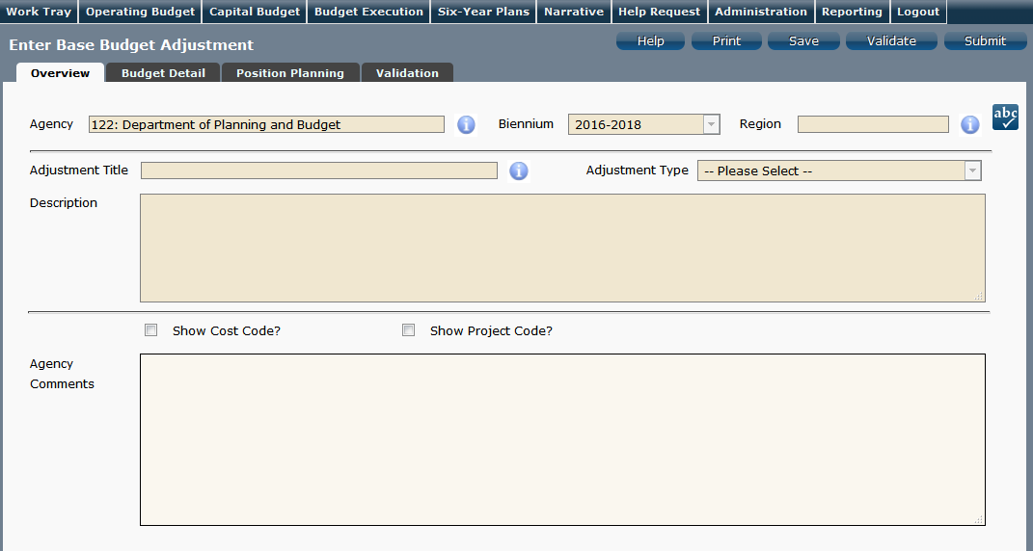
Overview Tab Instructions
- Click on the Overview tab.
- Select the Agency to which the base budget adjustment will be applied.
- Select the Adjustment Title from the list of available adjustments prepared by DPB.
NOTE: After you have created a Base Budget Adjustment work item, it will no longer appear on the list of available adjustments in this list. Instead, you must access already created Base Budget Adjustment work items in the Performance Budgeting System work tray. In addition, if your agency has only one base adjustment on the list, it will auto-populate the work item with that adjustment.
- Confirm that the Biennium to which the base budget adjustment will be applied is correct.
- Select the Region of the state most impacted by the adjustment. If the adjustment impacts multiple regions, select "Multiple Regions".
- Read the DPB provided Description for the base budget adjustment.
- Check “Show Cost Code” and/or “Show Project Code” If the Budget Details for the base budget adjustment will be entered at the Cost Code Level, Project Code Level, or both.
- Enter any Agency Comments for the base budget adjustment.

Budget Detail Tab

Budget Detail Tab Overview
The purpose of the Budget Detail tab is to capture the budget details, line by line, for the base budget adjustment. You will be required to enter the Program, Fund, Subobject, and Year 1 and Year 2 dollars for each line item associated with the base budget adjustment. Note: The Position Planning tab must be used to budget for any authorized positions associated with the base budget adjustment.
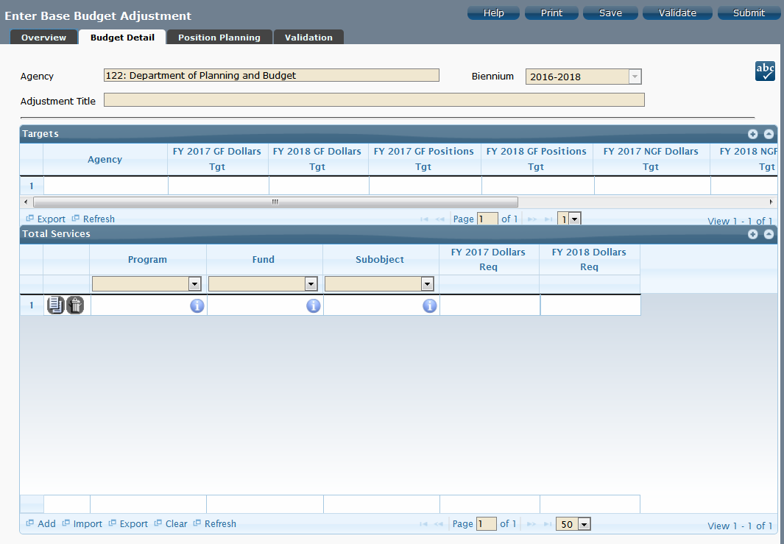
Budget Detail Tab Instructions
- Click the Budget Detail tab.
- Take note of any DPB targets in the Targets grid for the base budget adjustment. The budget details in the Total Services grid must match the general Fund and nongeneral Fund targets for dollars and positions for each year of the biennium before the base budget adjustment can be submitted to DPB.
- Confirm the Personal Services data in the Total Services grid if the Position Planning tab was used to budget for positions. If the data is incorrect, return to the Position Planning tab to make corrections and then repopulate the data as described in the Position Planning tab instructions.
- In the Total Services grid, enter the Program, Fund, and Subobject for each line item. Additionally, if applicable for the line item, enter the Cost Code and/or Project Code.
- Enter the FY 20XX Dollars for the line item, where XX represents the first and second years of the biennium.
- Add rows to the Total Services grid as needed to specify multiple Non-personal Services budget lines.

Position Planning Tab

Position Planning Tab Overview
The purpose of the Position Planning tab is to record the authorized positions associated with a base budget adjustment. Additionally, users can optionally use the position planning tab to calculate by position or role, the dollar budget date associated with any authorized positions associated with the adjustment. Once the positions are entered, the personal services budget can be automatically calculated and the resulting budget data can be used to populate the personal services subobjects in the Total Services grid. Users can opt out of using the position planning calculation functionality and are only required to enter the total number of authorized positions.
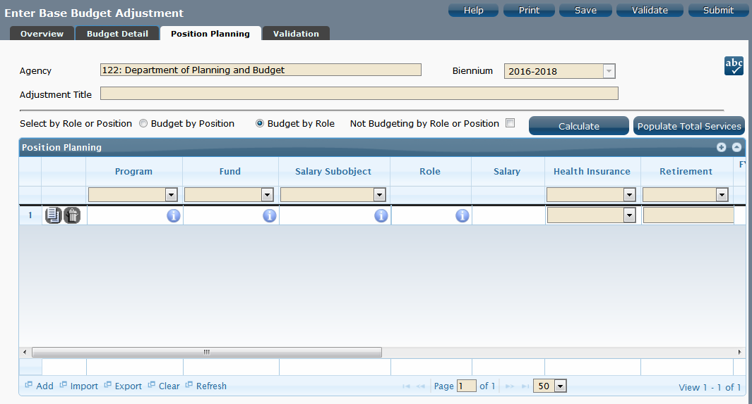
Position Planning Tab Instructions

Not Budgeting by Position or Role
Use this method if you do not need to calculate the cost of positions in the Performance Budgeting System and only want to record the authorized position level associated with the base adjustment.
- Click on the Position Planning tab.
- Check the Not Budgeting by Position or Role checkbox.
- In the Position Planning grid, enter the total number of positions for the Agency for both the first year and second years of the biennium in the FY 20XX Positions cells.
- Add rows to the Position Planning grid, by clicking the Add button in the lower left corner of the grid as needed.
- Authorized positions can also be uploaded from an .xls file.

Position Planning by Role
Use this method if you would like to use the capabilities of the Performance Budgeting System to assist in the calculation of the dollar costs of positions associated with the base adjustment.
- Click on the Position Planning tab.
- Select the Role radio button.
- In the Position Planning grid, enter or edit the Program, Fund, and Subobject for a role. Additionally, if applicable for the role, enter the Cost Code and/or Project Code.
- Select or edit the Role.
Enter the proper role title for the position you are requesting. Please contact the Department of Human Resource Management (DHRM), the DHRM website, or your agency human resource department for this proper role title.
- Enter or edit the Salary for the selected role.
Enter the base salary for the position being requested. Do not include any benefit amounts. The requested amount must be within salary range and should be based on starting salaries for recent hires in this role.
- Select or edit the Health Insurance for the role.
Select a health premium. You can select the statewide average, or the actual employers premium for single, employee plus one, and family coverage.
- Select or edit the Retirement for the role.
Select the retirement type for the position: regular VRS, VaLORS, SPORS, judges' retirement, or defined contribution.
- Enter or edit the number of pay periods for the role for the first year of the biennium in the FY 20XX Pay Periods cell if the role is valid for the first year of the biennium.
- Enter or edit the number of positions allocated to the specified role for the first year of the biennium in the FY 20XX Positions cell if the role is valid for the first year of the biennium.
- Enter or edit the FY 20XX Pay Periods and FY 20XX Positions, where 20XX is the second year of the biennium. Data will only be entered for the second year of the biennium if the role is valid for the second year of the biennium.
- Add rows to the Position Planning grid, by clicking the Add button in the lower left corner of the grid as needed.
- Once all roles have been added to the Position Planning grid, click the Calculate button to calculate the dollar impact for both years of the biennium for the specified roles. This calculation is based upon the data entered for each role.
- Confirm the calculation of the budget for both the first and second years of the biennium FY 20XX Budget. If the amounts are not correct, edit the values entered for a role and recalculate the budget for that role.
- Once the budget for both years of the biennium for each role is satisfactory, click the Populate Total Services button to calculate the personal services amounts for the Budget Details tab based upon the data entered in the Position Planning grid.

Position Planning by Position
Use this method if you would like to use the capabilities of the Performance Budgeting System to assist in the calculation of the dollar costs of positions associated with the base adjustment.
- Click on the Position Planning tab.
- Select the Position radio button.
- In the Position Planning grid, enter or edit the Program, Fund, and Subobject for the role. Additionally, if applicable for the position, enter the Cost Code and/or Project Code.
- Enter or edit the Position Title.
Enter the proper position title for the position you are requesting. Please contact the Department of Human Resource Management (DHRM), the DHRM website, or your agency human resource department for this proper title.
- Enter or edit the Salary for the selected position.
Enter the base salary for the position being requested. Do not include any benefit amounts. The requested amount must be within salary range and should be based on starting salaries for recent hires in this position.
- Select or edit the Health Insurance for the position.
Select a health premium. You can select the statewide average, or the actual employers premium for single, employee plus one, and family coverage.
- Select or edit the Retirement for the position.
Select the retirement type for the position: regular VRS, VaLORS, SPORS, judges'retirement, or defined contribution.
- Enter the number of pay periods for the position for the first year of the biennium in the FY 20XX Pay Periods cell if the position is valid for the first year of the biennium.
- Enter or edit the number of positions allocated to the specified position for the first year of the biennium in the FY 20XX Positions cell if the position is valid for the first year of the biennium.
- Enter or edit the FY 20XX Pay Periods and FY 20XX Positions, where 20XX is the second year of the biennium. Data will only be entered for the second year of the biennium if the position is valid for the second year of the biennium.
- Add rows to the Position Planning grid, by clicking the Add button in the lower left corner of the grid as needed.
- Once all roles have been added to the Position Planning grid, click the Calculate button to calculate the dollar impact for both years of the biennium for the specified positions. This calculation is based upon the data entered for each.
- Confirm the calculation of the budget for both the first and second years of the biennium FY 20XX Budget. If the amounts are not correct, edit the values entered for one or more positions and recalculate the budget for that those positions by repeating step 12.
- Once the budget for both years of the biennium for each position is satisfactory, click the Populate Total Services button to calculate the personal services amounts for the Budget Details tab based upon the data entered in the Position Planning grid.

Base Budget Adjustment Bulk Submit Instructions
Performance Budgeting System
Bulk Submit Overview
The purpose of the Base Budget Adjustment Bulk Submit to DPB module is to allow an agency to submit all their base budget adjustments to DPB at once.
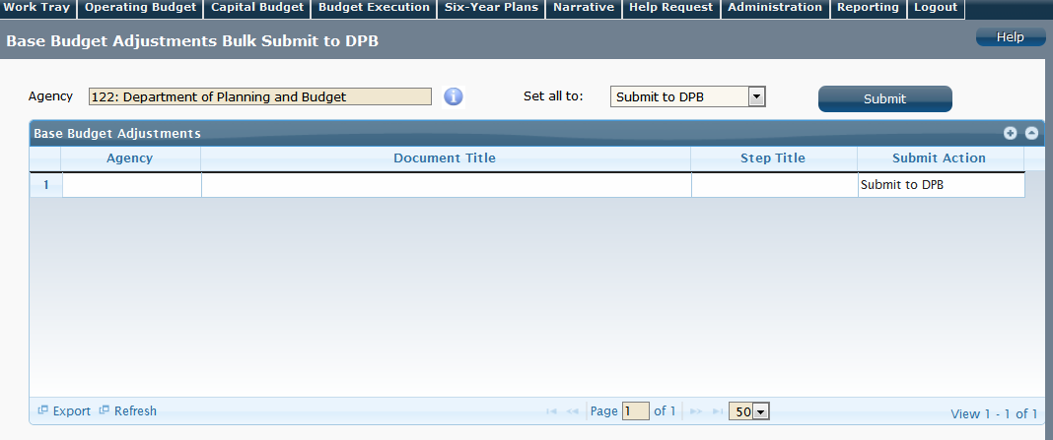
Bulk Submit Instructions
- To ensure that all requests are accounted for, look at the Document Title column to review the base budget adjustments.
- Confirm that the Step Title and State fields are correct for each of the base budget adjustments.
- To bulk manage the submit action, click the Set all to dropdown and select the submit action that the requests require: Submit to DPB, Continue Review, or Return to Previous Submitter. If submitting to DPB, all requests must be set to Submit to DPB. The submit actions correspond to the submit actions in the base budget adjustment documentation.
- Click the Submit button. A message will display in the text box below the submit button to alert you that the submit was successful.

